Norfolk County Council proposes to make a Temporary Traffic Regulation Order (the “Order”) (NTRO10657) affecting the A1242 Yarmouth Road from 50 metres east of its junction with Thorpe Hall Close for 50 metres eastwards (the “Road”) in the Town of Thorpe St. Andrew to facilitate new sewer connection works, the Road will be temporarily closed (except for pedestrian access) for the duration of the works/period the closure is necessary which is anticipated to be from 19th to 30th January 2026, but may continue to be closed/restricted until the 13th March 2026 where the closure is still required beyond the anticipated dates.

Alternative route is via: A1242 Yarmouth Road, A1042 Pound Lane/ Ring Road/ Saint Williams Way/ St Williams Way/ Harvey Lane/ Mousehold Lane, A1151 Sprowston Road/ Magdalen Road/ Bull Close Road/ Charlton Road, A147 Barrack Street/ Bishop Bridge Road/ Riverside Road/ Riverside/ Koblenz Avenue/ Canary Way/ Carrow Road, A1242 Clarence Road/Thorpe Road/ Carrow Road/ Yarmouth Road.

The works promoter for this restriction/closure is: RMR Construction Group.

Vehicular access will be permitted to a final destination in the Road where signs indicating such access is possible and permitted are in place.

The Order shall automatically revoke on the completion of the works when the closure is no longer necessary or otherwise on the 13th March 2026 without further notice.

If necessary, the restriction could run for a maximum period of 18 months from the date the Order is effective.

A person who contravenes, or who uses or permits the use of a vehicle in contravention of the closure imposed by the Order shall be guilty of an offence.

Penalty: £1000 maximum fine on conviction and/or endorsement for contravention.

In the event of the start date being delayed the new start date will be displayed on site in advance.

Full details on the closure are available at https://one.network. Any enquiries that cannot be answered on the one.network website should be directed to the North Area Streetworks (Infrastructure Department) contactable by telephone at 0344 800 8020 or email at streetworks@norfolk.gov.uk

Dated this 9th day of January 2026.

Katrina Hulatt
Director of Legal Services (nplaw)
County Hall
Martineau Lane
Norwich
NR1 2DH

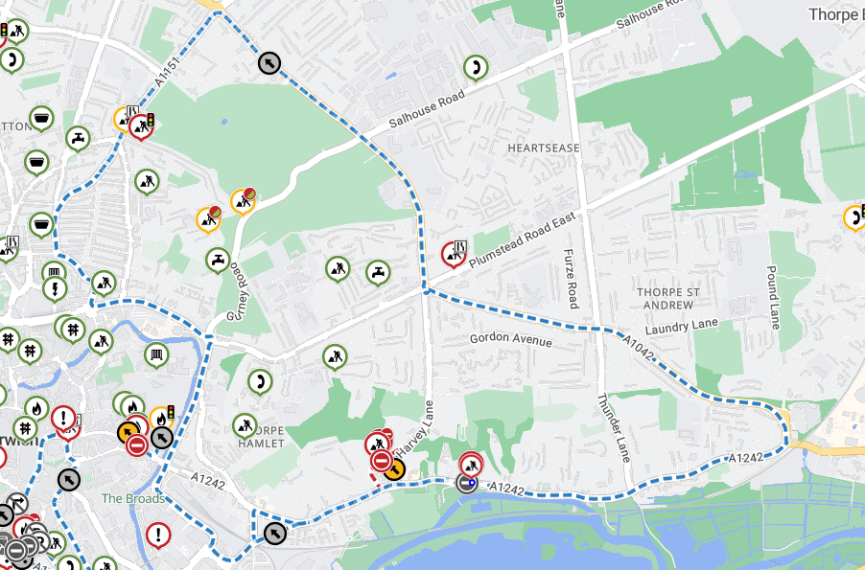
Imagery © 2025 MapTiler | Imagery © 2025 Hexagon | © MapTiler © OpenStreetMap contributors

